Practices for Lesson 11: Building Siebel Workflow Processes in Siebel IP 2020

Practices for Lesson 11

**Overview**

In these practices, you will learn to create a Workflow process using Siebel Composer and test the Workflow.

Practice 11-1 Creating a workflow process using Siebel Composer

**Overview**

In this practice, you will define a workflow that creates a child activity plan for an opportunity record, then navigates the user to a view that displays the new plan. The workflow then waits for the user to enter more data and save changes before continuing.

Assumptions

You should have completed the Practices of Lesson 10.

**Tasks**

1. Open the Web Tools URL – 4430/Siebel/app/webtools/enu. Provide the username and password given below and click **Login**.

Username: Sadmin

Password: XXXXX

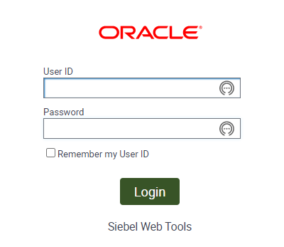

1. You will see object Explorer in left hand side and Object description view in Right hand Pane.

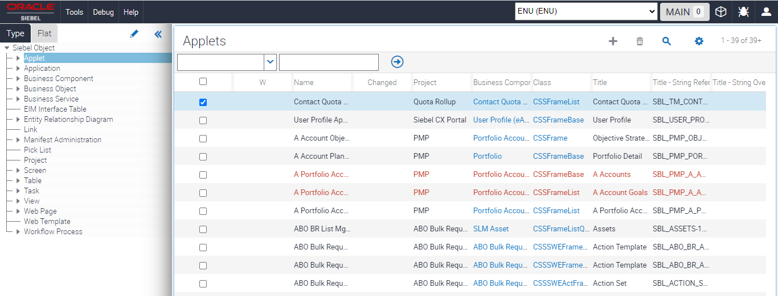

1. Click on Workflow Process in Left Hand side – Object Explorer and observe the + not highlighted for you. You have to create workspaces to move further.
2. Create Workspace.
   1. Click **Cube** Icon on the Application Title Bar.
   2. In a likely instant creation of using the same instance, workspaces can be created with initials so there are no issues of conflict.
   3. Click **Create.**
   4. Provide the workspace name **–** workflow01
   5. Provide the comments

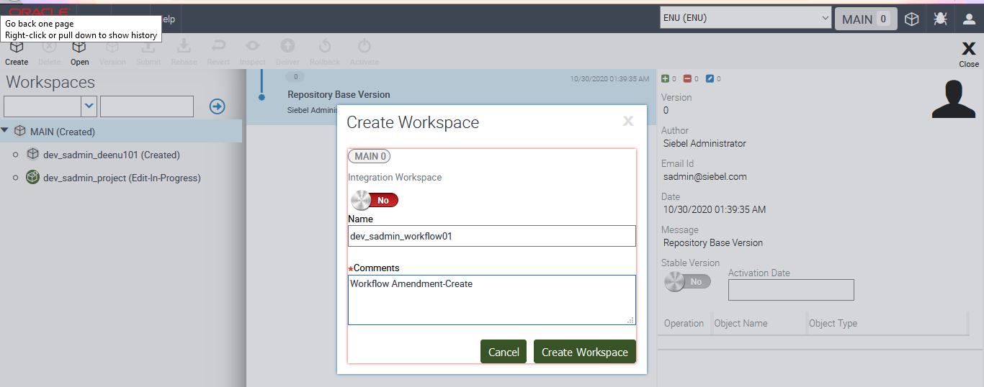

* 1. Click **Create Workspace** button.
  2. Click **Close X button** at right side of window.
  3. Observe the **Edit and +** coming up for you now.

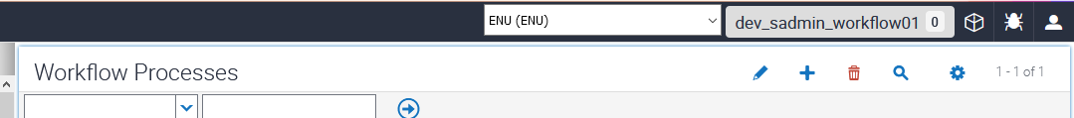

1. Create a Workflow G
   1. Go to Object Explorer and select **Project** from the Explorer menu
   2. Create the Project named AUT Workflow as you will be assigning new object definitions to that project.
   3. Click **+** and provide the name of project as **AUT Workflow**. Enable the **Locked** In. Click **Save Record**.

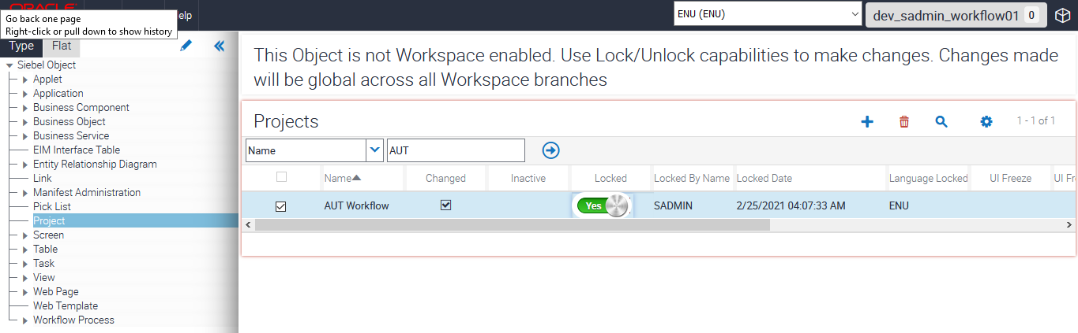

1. Create a workflow process object definition and invoke the workflow designer.
2. In the Object Explorer (OE), select Workflow Process.
3. Click + to create new record.

|  |  |
| --- | --- |
| **Property** | **Value** |
| Process Name | Create Plan |
| Business Object | Opportunity |
| Workflow Mode | Interactive Flow |
| Project Name | AUT workflow |

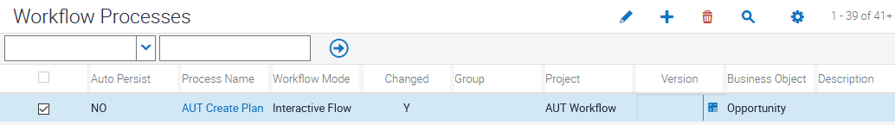

1. Click **Save Record**.
2. Click **the Edit Icon (Pencil Icon)**. It opens up the workflow designer.
3. Defining Workflow step properties

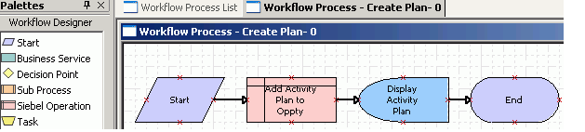

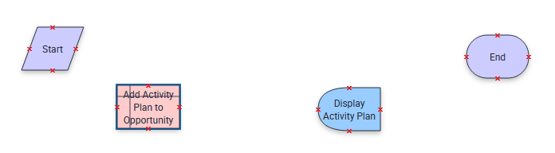

1. Open the Palette and drag the components and name the objects accordingly as shown below. Use connectors and connect them accordingly.

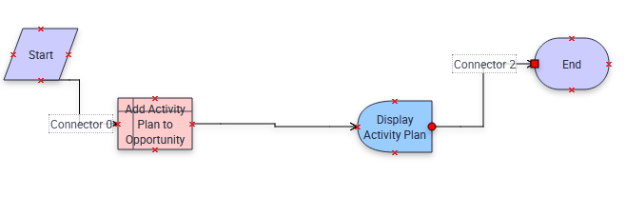

1. In the Process Designer canvas, click the Add Activity Plan to Oppty step.
2. In the Properties window, define the business component to use for the operation and the operation to be performed by entering values described in the following table:

|  |  |
| --- | --- |
| Property | Value |
| Business Component | Activity Plan |
| Operation | Insert |

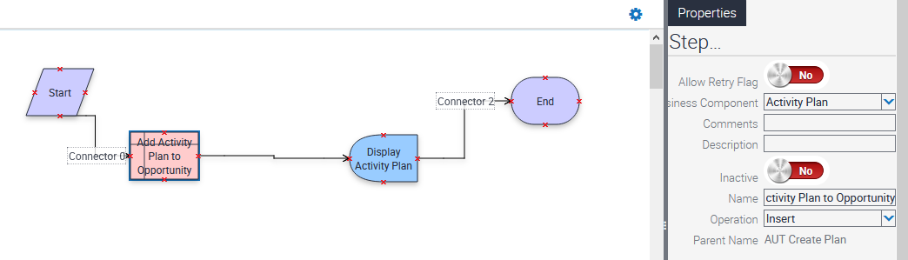

1. When you perform an Insert operation on a business component, you must supply a value for required fields in the business component. In particular, to insert a new activity plan, you must provide the name of the activity plan template.
2. With the Add Activity Plan to Oppty step still chosen, in the MVPW add a new input argument using values described in the following table:

|  |  |  |
| --- | --- | --- |
| Field Name | Type | Value |
| Template | Literal | Introductory Sales Call. |

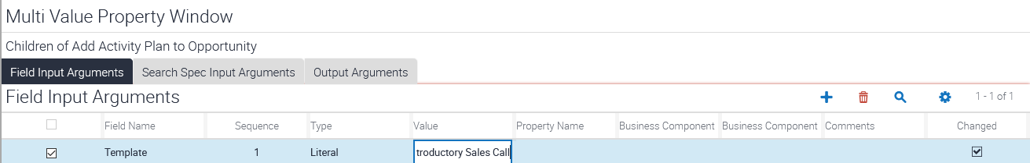

1. In the Process Designer canvas, choose the Display Activity Plan step.
2. Use the Properties window to define which view is displayed for the Display Activity Plan user interact step. Use values described in the following table:

|  |  |
| --- | --- |
| Property | Value |
| User Interact View | Opportunity Activity Plan |

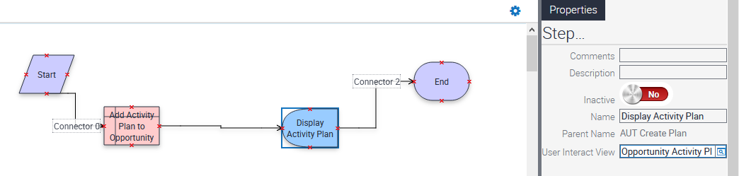

1. Click the connector located between the Display Activity Plan step and the End step, then define properties in the Properties window using values described in the following table:

|  |  |
| --- | --- |
| Property | Value |
| Event Object Type | BusComp |
| Event | WriteRecordUpdated |
| Event Object | Activity Plan |
| Type | Condition |

**Note:** For the Event and Event Object picklists to populate correctly, you must specify the Event Object Type first.

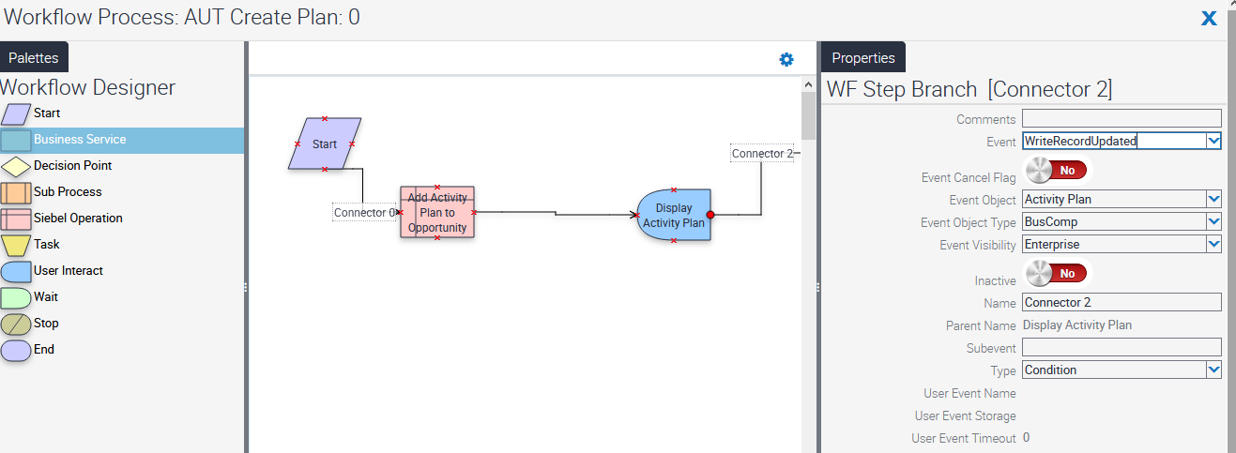

12. The Siebel Workflow will be tested in next Practices.

**Practice 11-2: Testing Siebel Workflow**

**Overview**In this practice, we will test an existing service through business simulator.

Assumptions

You should have completed the Practice 11-1.

**Tasks**

1. From the APP URL or through the call center URL – Visit the Site Map and access the following. (https://public-ip-address:4430/siebel/app/sales/enu)
2. Navigate to the Administration - Business Service screen, Simulator view.

1. Click on (+) on the Screen for Simulator

1. Choose the Service name by clicking the Search Button in the Service Name field and choose **eTraining Test Service**. Click **OK** to continue.

1. In the method Name – Click on Search Button and choose the Function **CanLaunchTest** as below.

1. Choose the number of Iterations as 2 and click **Run**.

**Note**: The Simulator runs the specified number of iterations and loops through the test cases in order. If you have defined multiple input arguments, you can choose to run only one argument at a time by clicking Run On One Input. The result appears in the Output Property Set applet.

1. When the output arguments are created, click **Move To Input** to test the outputs as inputs to another method.

